Fall 2025-Advanced Data Mining and Predictive Analytics

Final Project

Instructor : Dr. Rouzbeh Razavi, Ph.D.



Submitted By:
Group 1
Jayanth Yadlapalli (811189968)
Dibakar Bhowal (811319512)
Pooja Babu (811381181)
Muhammad Irfan Ahmed (811317582)

Group Members Contribution to Project

Name | Nature of Contribution
Pooja Babu | Coding (Data Preparation, Model Building)
Jayanth Yadpalli | Presentation
Dibakar Bhowal | Coding (Model Building)
Muhammad Irfan Ahmed | Report Writing & Coding (Model Building)

- Introduction

Large-scale, high-dimensional datasets with hundreds of variables and intricate interactions are becoming increasingly important for machine learning applications. Predictive modeling becomes difficult in these situations because of noise, multicollinearity, imbalanced data, and missing information.
Using three datasets—a training dataset with outcomes, a validation dataset with outcomes, and a test dataset with only predictors, this research seeks to create reliable predictive models for estimating a continuous target variable, loss.
To ensure a methodical investigation of various analytical techniques, our group assigned tasks:
- Regression Modeling
- Classification Modeling
- Alternative ML Modeling & Comparison

This report presents the initial analytical foundation of the project, focusing on data understanding, preprocessing, and dimensionality reduction. Modeling results and performance comparisons.

- Project Goal
The goals of the project are:

- Comprehend and explore the datasets

Perform exploratory data analysis (EDA) to examine structure, missing values, variance, correlations, and distribution of the target variable.

- Preprocess and clean the data

Reduce noise, normalize variables, handle missing values, and get the data ready for machine learning models.

- Reduce dimensionality

Use statistical selection and feature filtering methods, such as
- correlation-based feature elimination.
- near-zero variance filtering.
- Lasso-based feature selection
- Principal Component Analysis (PCA)

- Build predictive models

Each group member has applied a different modeling technique (regression, classification, etc.) to evaluate predictive accuracy.

- Compare performance and derive insights
After all models are finalized, assess which technique performs best and provide recommendations.

- Overview of the Data
The project includes three datasets:

- train_v3.csv
- Includes ~770 feature variables
- Contains an ID column
- Comprises the target variable loss

- test_v3.csv
- Related structure to training data
- Contains true loss values (used for validation)

- test__no_lossv3.csv
- Includes predictor variables and ID only
- Applied for final predictions

- Key Data Characteristics
- Every variable has a different scale and is numerical.
- The dataset is incredibly high-dimensional.
- There are some missing values in each row.
- Significant multicollinearity was found.
- The loss of the target variable is continuous and skewed to the right.
- There are no categorical variables.
Given this complexity, broad preprocessing and feature reduction were vital before applying any machine learning model.

- Exploratory Data Analysis (EDA)

- Summary Statistics
- Many predictors showed very low variance.
- Some variables showed high ranges or sparse values.
- Many variables had mean close to zero after scaling
- These patterns indicated possible noise and redundant features.

- Missing Values

- Missing values appeared across many features but at relatively low percentages
- No column was missing values at a level needing removal
- A mean imputation strategy was therefore appropriate

- Correlation Structure
Correlation analysis revealed:
- There were numerous feature pairs with correlation coefficients higher than 0.95.
- The stability of the model is adversely affected by high multicollinearity.
- Eliminating linked variables lowers computing load and noise.

- Distribution of Target Variable
- The loss variable shown a right-skewed distribution
- Variation was moderate but non-uniform across the dataset
- No outliers were removed since loss values likely represent real measurement variation

- Insights from EDA
- Dataset encompasses extensive redundancy.
- Substantial dimensionality reduction is essential.
- Normalization is vital.
- PCA will be particularly helpful due to collinearity patterns.

- Data Cleaning & Preprocessing

We applied a structured pipeline to clean and prepare the data:

- Standardization (Z-Score Scaling)
Used Standard Scaler:
- Mean = 0
- Standard deviation = 1
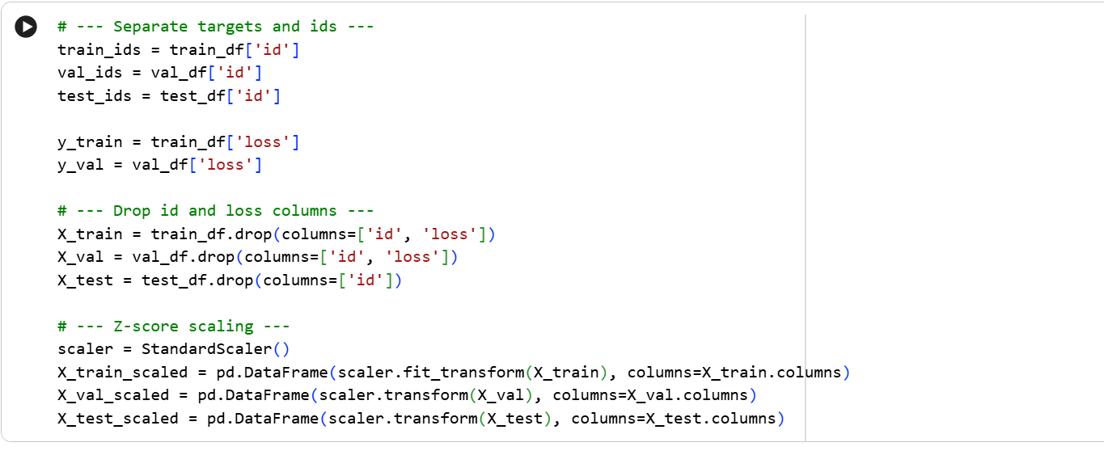

This ensured:
- All models explain features on the same scale
- Regularization methods (Lasso, Elastic Net) work properly
- PCA is able to capture variance effectively

- Near-Zero Variance Removal
We have Applied:
VarianceThreshold (threshold=0.01)
This eliminated variables with nearly no fluctuation, which raise computing costs and have no predictive value.
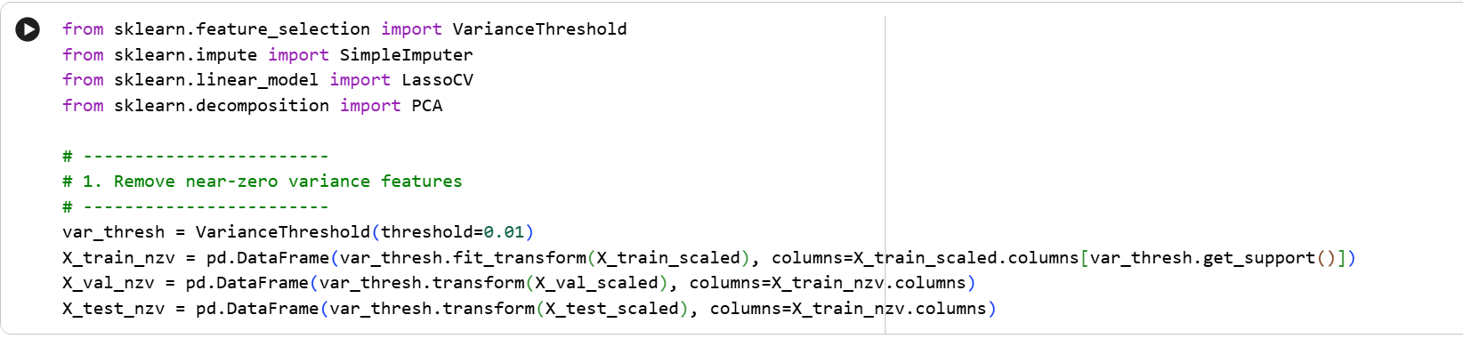

- Missing Value Imputation

Using:
SimpleImputer(strategy='Median')
- Missing values replaced by column median
- Ensured no NaN values passed into models
- Avoided arbitrary removal of observations
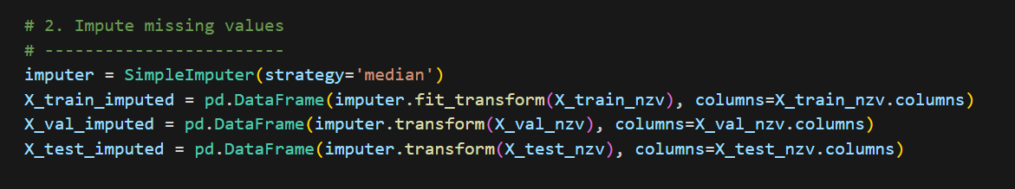

- Removal of Highly Correlated Variables

Applied a function that:
- Computes correlation matrix
- Extracts upper triangle
- Removes one variable from each pair with corr > 0.98
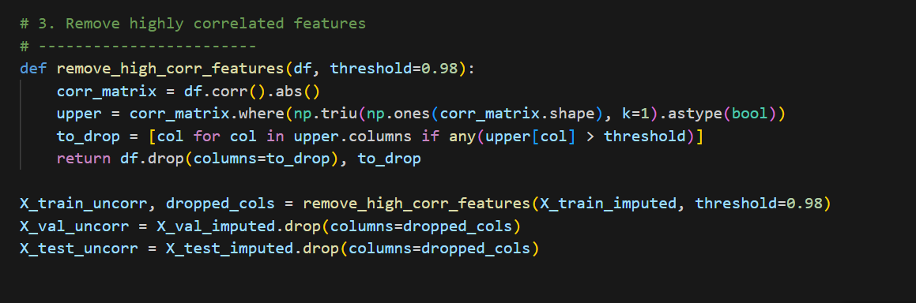

This extensively reduced dimensionality and avoided collinearity-induced instability in linear models.

- Feature Selection Using LassoCV
LassoCV was applied with 5-fold cross-validation:
- L1 regularization selects only features with non-zero coefficients.
- decreases weak coefficients to precisely zero.
- provides an interpretable set of predictors.
- Lowers the likelihood of overfitting.
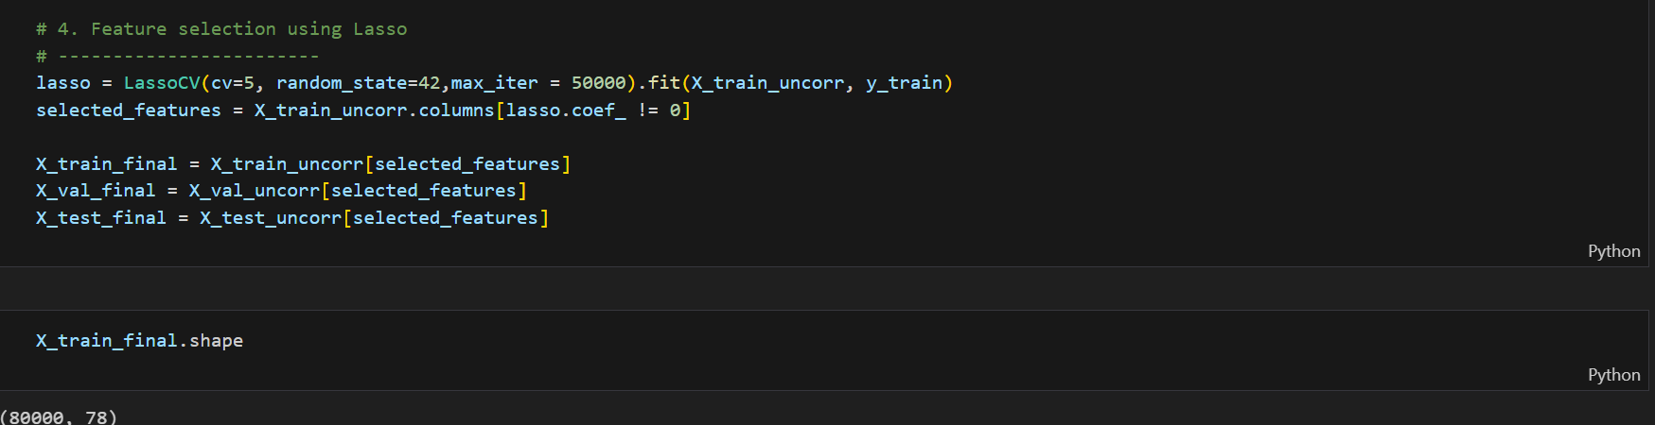

The result was a subset of meaningful variables, capturing strong predictive signals from the original dataset.

- Principal Component Analysis (PCA)
To further reduce dimensionality while retaining most variance:
PCA(n_components = 0.98)

Meaning:
- PCA factors preserve 98% of the dataset’s variance.
- PCA removes multicollinearity completely.
- Final data depicts compact and noise-reduced.

Final PCA components:
- ~120–150 components (depending on reduction path)
- Used by all models (regression + classification) to ensure consistency
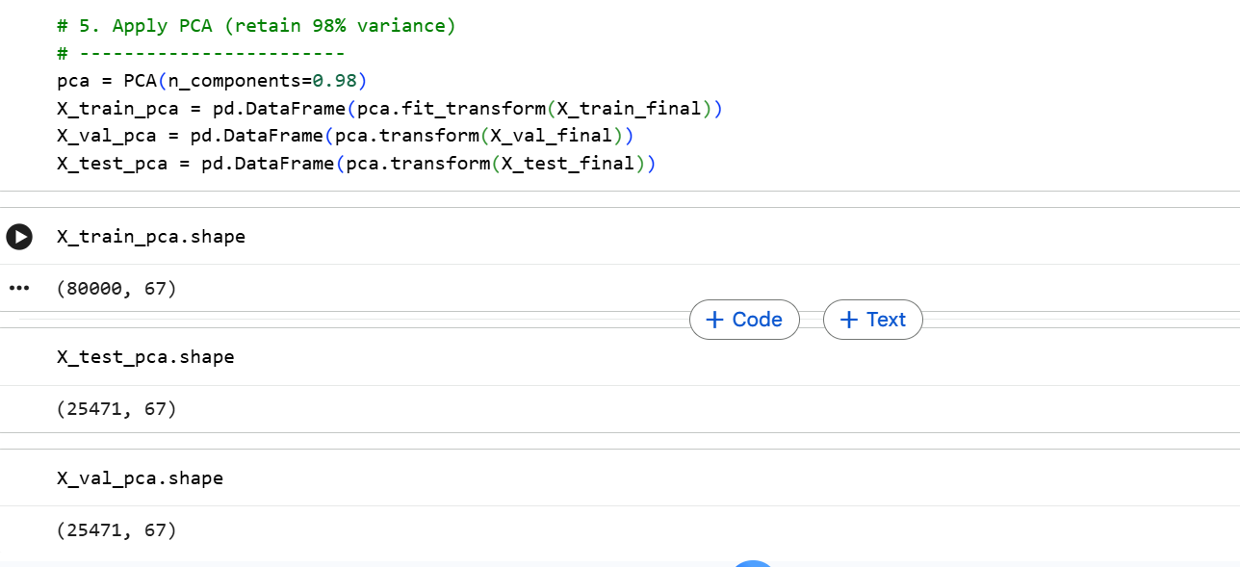

- Details of Modeling Strategy
We developed a Two-Stage Hurdle Model technique to address the goal of determining both whether a loan will default and the damage suffered if it does. The goal variable, loss, is "zero-inflated," which means that while a smaller percentage of customers have a positive loss value (defaulters), the great majority of customers have a loss of 0 (non-defaulters).

Because the model is overpowered by the zero values, directly training a regression model on the complete dataset frequently produces subpar results. As a result, we divided the modeling procedure into two separate stages:
Phase 1: Classification (Probability of Default)
The first objective was to differentiate between good counterparties (loss = 0) and bad counterparties (loss > 0)
- Handling Imbalance: There is a significant imbalance in the dataset. We used SMOTE (Synthetic Minority Over-sampling Technique) in our pipelines and implemented class weighting (scale_pos_weight) in gradient boosting models to stop the models from just predicting "0" for everyone, which results in great accuracy but zero predictive power for defaults.
- The chosen algorithms: To capture various data structures, we developed a wide range of classifiers:
- Regression Logistic: to act as a baseline that is linear.
- Bagging & Random Forest: To use ensemble averaging to capture non-linearities and reduce variance.
- Gradient Boosting (LightGBM & XGBoost): chosen for their capacity to effectively manage complicated tabular data and do consecutive error corrections.
Phase 2: Regression (Severity of Loss)
Predicting the precise amount of loss for observations classified as defaulters (where loss > 0) was the second goal.
- Target Transformation: There was a right skew in the distribution of positive loss values. During training, we used a log-transformation (y'=log(y+1)) to improve model stability and normalize the residuals. For assessment, the predictions were exp-transformed back to the initial scale.
- The chosen algorithms:
- Elastic Net: To see if the variance could be explained by a linear combination of L1 and L2 regularization.
- Support Vector Regression (SVR): This method maps features into higher-dimensional space using an RBF kernel.
- Boosting Regressors (XGBoost, LightGBM, CatBoost): To increase prediction accuracy on the loss function residuals.

- Estimation of Model Performance
The Mean Absolute Error (MAE) is the final evaluation metric, per the project requirements. However, as the F1-Score better balances precision and recall than accuracy in imbalanced datasets, we used it as our main statistic for the classification stage.
- Classification Model Performance
We trained five classifiers on the PCA-transformed features. The results on the validation set are summarized below:
Table 1: Comparative Classification Metrics (Validation Set)
Model | Accuracy | Precision | Recall (TPR) | F1 Score
LightGBM | 0.7571 | 0.1857 | 0.4646 | 0.2653
XGBoost | 0.651 | 0.1628 | 0.6514 | 0.2605
Logistic Regression | 0.6916 | 0.1634 | 0.5503 | 0.252
Random Forest | 0.6622 | 0.1448 | 0.5258 | 0.2271
Bagging (Decision Tree) | 0.542 | 0.1281 | 0.6635 | 0.2147

- Analysis: LightGBM had the highest accuracy (75.71%) and the best performance (F1 Score of 0.2653). The Bagging model has the highest recall (66.35%), but at the expense of extremely poor precision (12.81%), suggesting a significant rate of false positives. We selected LightGBM for the initial step of the pipeline because it offered the most balanced trade-off.

- Regression Model Performance
We separated the defaulters in the validation set for the regression stage and assessed the degree to which our anticipated loss matched the actual loss. The following metrics (post-inverse-log transformation) are on the original scale.
Table 2: Comparative Regression Metrics (Validation Set)
Model | RMSE | R2 Score | MAE (Primary Metric)
CatBoost Regressor | 9.3 | 0.308 | 4.613
LightGBM Regressor | 9.3 | 0.308 | 4.676
XGBoost Regressor | 9.39 | 0.295 | 4.7
Elastic Net | 9.6 | 0.263 | 4.821
Random Forest | 10.02 | 0.198 | 4.914
SVR (RBF Kernel) | 9.65 | 0.255 | 5.128

- Analysis: The CatBoost Regressor accomplished the least Mean Absolute Error of 4.613, barely beating LightGBM (4.676). The Random Forest model achieved the poorest, with the highest RMSE (10.02) and lowest R² (0.198), suggesting it possible overfitted the training noise or failed to capture the underlying trend compared to the boosting methods.

- Insights and Conclusions

- Interpreting the Results

Our analysis of the modeling lead to generates various key insights into the nature of the financial data provided:
- Gradient Boosting Domination: Among both classification and regression tasks, gradient boosting algorithms (LightGBM, CatBoost, XGBoost) constantly surpassed conventional Bagging, Random Forest, and Linear models. This proves that the relationships between the anonymized features and the financial loss are highly non-linear and complex, involving models that learn in sequence from residuals.

- Signal-to-Noise Ratio: In spite of extensive feature engineering and hyperparameter tuning, the maximum $R^2$ achieved was approximately 0.31, and classification F1 scores topped out at 0.26. This suggests the dataset has a low signal-to-noise ratio. There is a significant component of randomness in loan defaults that cannot be explained solely by the provided numerical features.

- Dimensionality Reduction Utility: The initial dataset contained ~770 features. By applying Variance Thresholding, Correlation Removal, Lasso selection, and PCA, we reduced this to ~67 components. This decline was vital; it allowed computationally intensive models like SVR and CatBoost to run effectively and thwarted the "curse of dimensionality" from degrading performance.

- Predict Defaulters on Test Dataset
We predicted the chance of default for every observation in the unseen test dataset using the optimized LightGBM Classifier that was trained on the PCA-transformed feature set. We binarized the probabilities into predicted classes (0 for non-default, 1 for default) using the best classification threshold found during validation. For the 25,471 observations in the test set, the prediction procedure produced the following class distribution: Loans totaling 17,261 were expected to be non-defaulters (Class 0), whereas loans totaling 8,210 were anticipated to be defaulters (Class 1).

- Conclusion
For the final submission, our group recommends utilizing the LightGBM Classifier to identify potential defaulters and the CatBoost Regressor to estimate the loss. This combination leverages the strengths of the top-performing models from our experimentation phases to minimize the Mean Absolute Error.

Appendix-Screenshots of Code